THE SERVICES

The loan of documents
The user must register with the Library to access its services. Books are borrowed for 30 days, while periodical articles are borrowed for 7 days.
Popular repertories, rare or valuable works, and the last number of periodicals are excluded from loan.
Tapes and films can be borrowed with the same modalities as books, for a maximum period of 3 days.
The material on loan can be reserved telephonically. The user will be notified when the book returns, and it must be picked up within 3 days from notification.

Interlibrary Loan (ILL and DD)
This service allows to consult and also take out volumes and documents that are present in other libraries through the Municipal Library of Roncade.
Interloan between libraries of the Province adhering to the Provincial Services Centre are free of charge to the user. Delivery time: maximum 4 days.
Interlibrary Loan and Document Delivery at a national and international level are paid services (€ 8,00 for Italian Interloan and € 12,00 for international loans)

Photocopies and bag deposit
It is possible to reproduce material owned by the library and not on loan, in real time, and according to the abiding laws.
Backpacks and bags can be deposited in the available lockers.


The digital Library always available

Digit http://tvb.bibliotechetrevigiane.it and discover free contents: newspapers, e-books, audio books, movies, music and all the “Biblioteche trevigiane” (Treviso libraries) entertainments.

SAFEGUARDING THE USERS’ RIGHTS

Relations with users
The policy of library personnel is to provide respect, courtesy and helpfulness towards users.
The personnel may ask people to leave the library or they may suspend them from using the services if they disturb other users, or if they treat documents and library furniture incorrectly or in case of disrespectful behaviour towards the library personnel.
The person in charge of the library can make exceptions in case of particular circumstances or special needs.

Information and participation
The Library obtains feedback from the users’ evaluations concerning the quantity and quality of the single services provided and in general on the quality of the service provided.
Users can suggest the purchase of documents not owned by the Library and they may present any other proposals to improve the services.

Complaints
Users have a right to complain about any inobservances concerning the commitments assumed by the Library in the Service Charter.
Complaints must be presented in writing or sent by fax or e-mail to the General Manager including details, address and telephone number of the person presenting the complaint.
The Person in charge will look into the matter, guaranteeing an answer within 30 days from the presentation of the complaint, activating procedures to eliminate any causes of problems.

Opening times
The library is open in the following hours:

MON 9.30-19.00
TUE 9.30-19.00
WED 9.30-19.00
THU 9.30-19.00
FRI 9.30-19.00
SAT 9.30-12.30

materiale prodotto in proprio

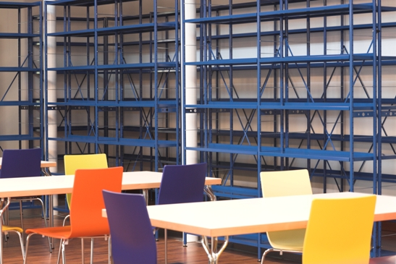

MUNICIPAL LIBRARY OF RONCADE

Via Dall’Acqua, 25
31056 Roncade (TV)
Tel. 0422 840593
Fax 0422 846224
e-mail: biblioteca@comune.roncade.tv.it
http://www.bibliotecaroncade.it

BibliotecaRoncade

BiblioRoncade


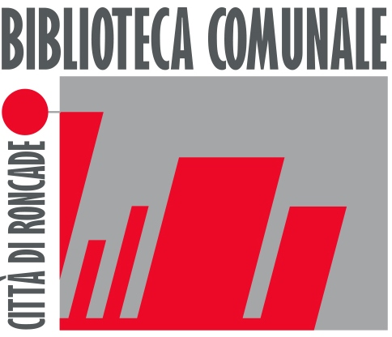
CITTA’ DI RONCADE

THE LIBRARY
The Municipal Library of Roncade is an institution that works to guarantee citizens the rights to obtain free access to culture, documents, information, expressions of human thought and creativity, according to the principles of the Italian Constitution on the fundamental rights of civil society and democratic living. The Library of Roncade, which is a fundamental and primary access point for citizens to information and documents, supports education over the entire lifespan. Moreover, it constitutes a reference point for different cultures and, at the same time, it contributes to increase awareness of cultural heritage, by passing it down to future generations. In addition, the Library intends to add value and incentivize the services about the documentation on the local reality.
Finally, the Library proposes itself as a patrimony to the community, opened to everybody and free of charge.

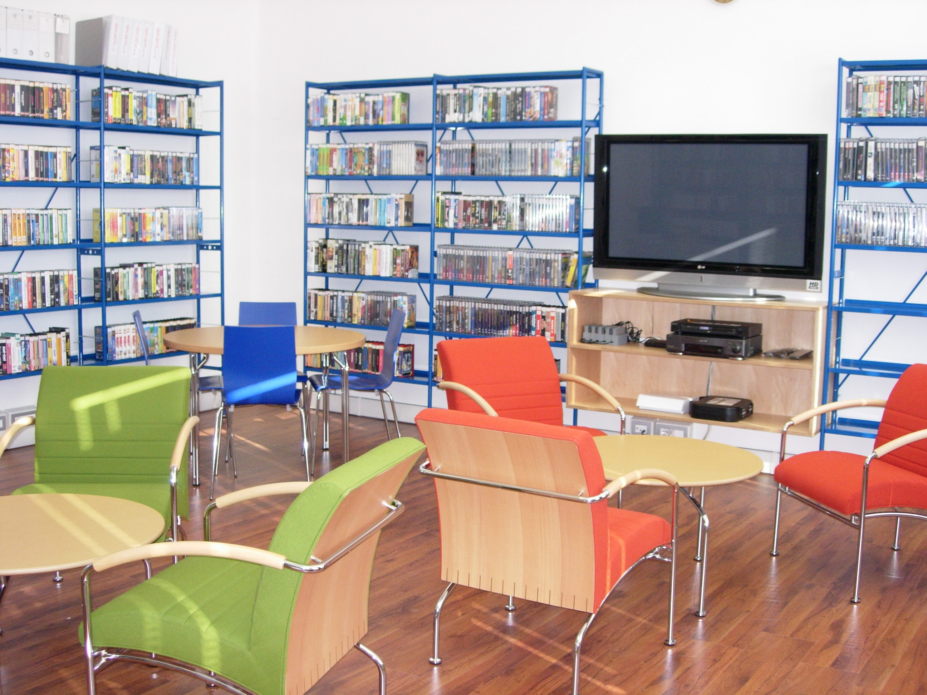
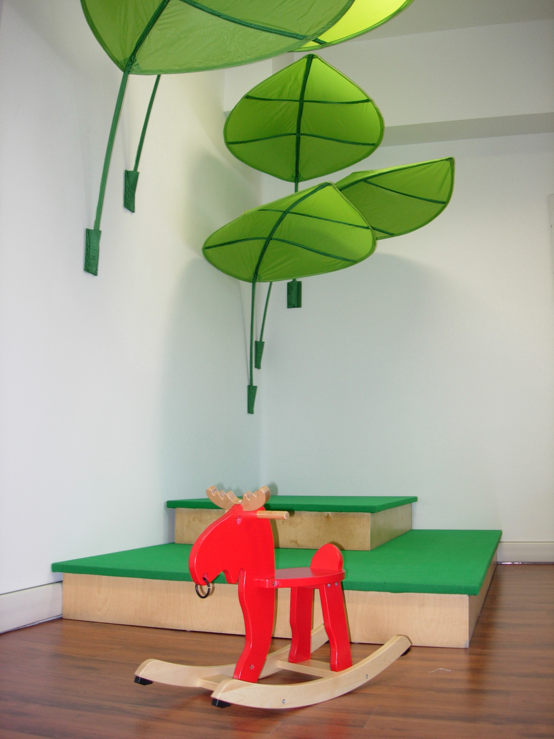
THE SERVICES
Consultation, reading and studying on site
The Library provides spaces especially for studying and reading. It is therefore possible to consult the library repertoire consisting of dictionaries, encyclopaedias, manuals, and other fundamental aids for research in a direct and immediate manner. The consultation of the catalogues and the relative bibliographical and documentary heritage of the Library can also be consulted directly and spontaneously by the user.
The bibliographical patrimony amounts to approximately 45.000 volumes. The library also owns about 3.000 photographic documents and a section of around 2.000 film and advertising posters.

Information services
The Library offers a service of bibliographical consultancy and assistance in the consultation of catalogues, informative and documentary research, and research on local or remote databases.
The library personnel instructs and orientates the user to utilize the resources, bibliography, and documentary material of the library independently. In case one needs complex informative material, the library staff is at disposal.

Computerized and multimedia services
The Library has documents and information on all kinds of supports, including video/audio and multimedia documents (compact-discs, videocassettes, DVD, VHS, CD-ROM).
The Municipal Library of Roncade has an internet and multimedia point for up to 6 people in order to access informative resources present on the web and also a Wi-Fi service (on payment).

Visually impaired section
The Library offers more than 600 documents, including books with big characters, high-legibility books, and audiobooks to blind users or to users with visual impairment.

The section on local history
The Municipal Library of Roncade collects documents of various kinds that constitute a testimony to the history and culture of the local community (at a provincial level).

THE SERVICES

Children’s section
The Library has two rooms dedicated to Children: one for the 0-6 age group and the other from 7-14 where the young users can read, study, work on research, or choose books to take on loan.
Parents are responsible for their children’s actions and use of the facilities and materials.
The Library collaborates with local schools and with other institutes, organizations and associations for the realization of projects that aim to diffuse literature among children; it organizes guided tours and workshops for students.
The Library also has approximately 400 table games, which, at present, may only be used on site.

Periodical section
At the time of printing the present Charter, a total of 45 periodicals are available to users.
Back years and periodicals out of print are partly kept in the library storehouse. Finally, it is possible to get previous numbers on loan.

Cultural promotion and activities, evaluation and research
TUTELA DEI DIRITTI DEGLI UTENTI
The municipal Library of Roncade arranges meetings, debates, presentations and other initiatives to promote the knowledge and use of its services, reading, information , literacy, the fruition of cultural expressions through various means, permanent formation, and dialogue among different cultures.
The Library promotes study and research activities aimed to the promotion and knowledge of documentary collections and aspects of local history and culture.

Video and sound section
This room has over 4000 films in VHS and DVD.
The database of titles is sectioned into film director, actors, genre and themes; the database is available on paper and computer supports. The users may ask for a copy in digital format. The sound section is currently composed of 300 audio documents.

